Group 1- virtual house

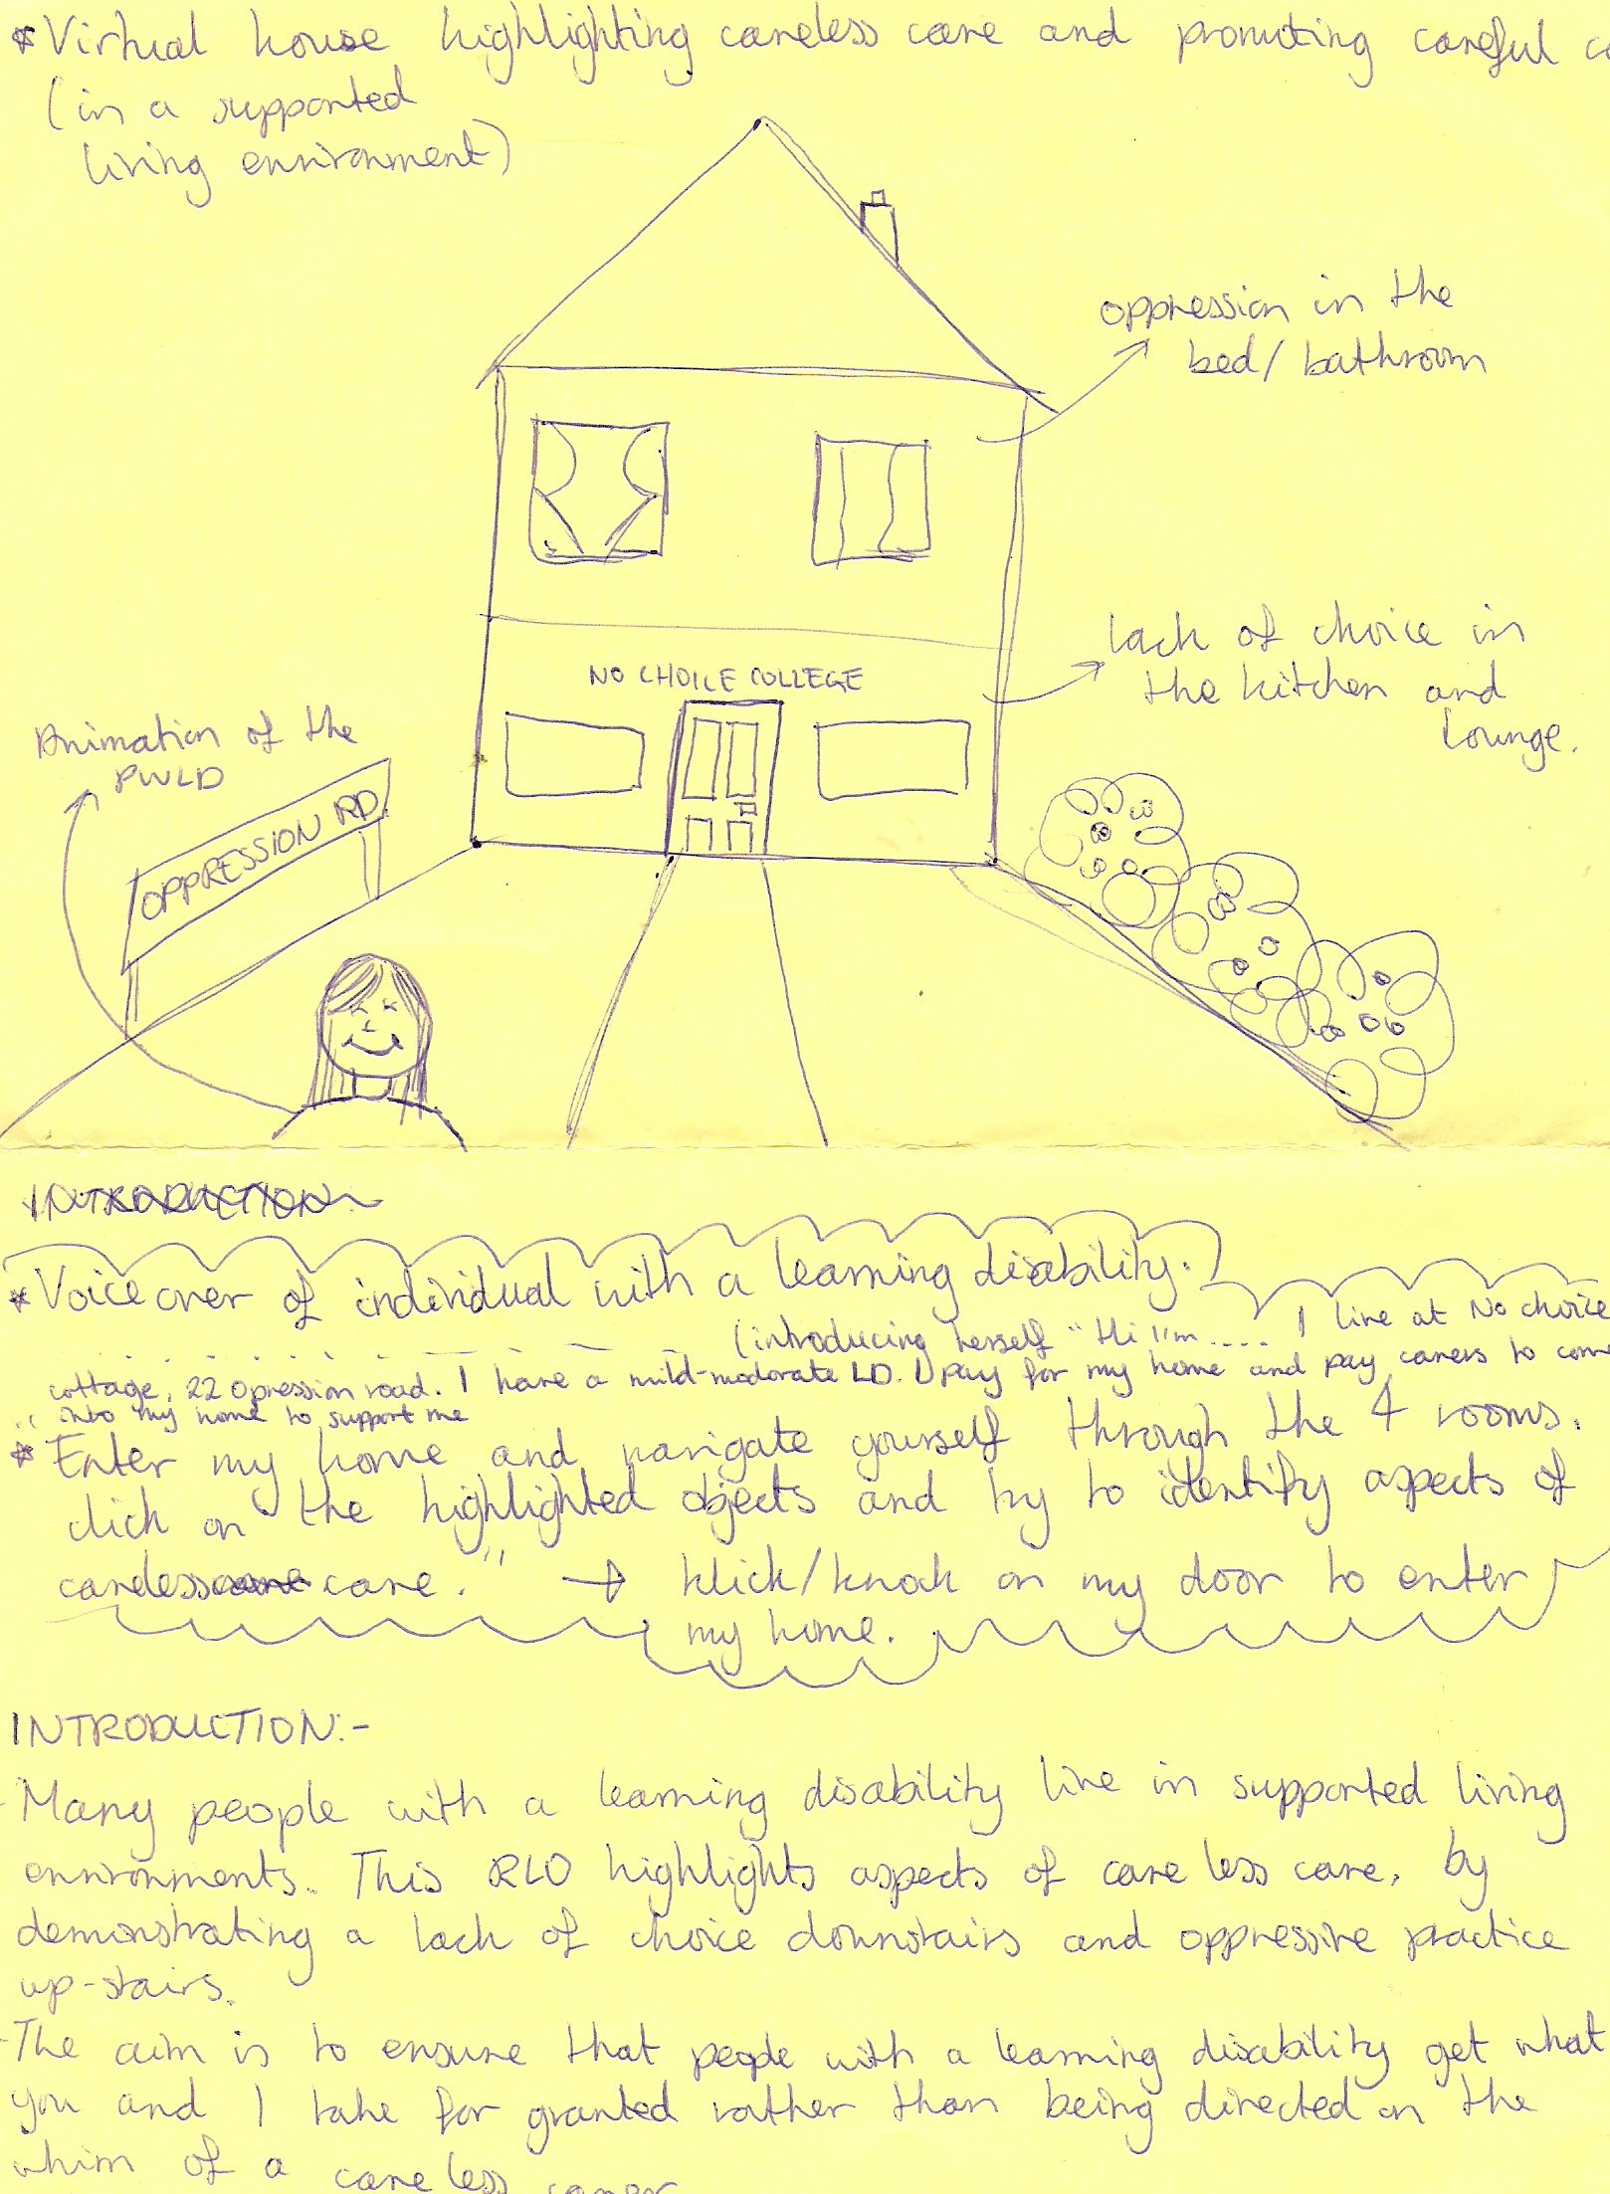

DIALOUGE

Introduction

Written introduction on screen (above)
THEN
Screen showing image of the front of the house

- Service user:
    - Hi, I’m ………………………….
    - I live at No Choice Cottage, 22 Oppression Road
    - I have what they call a mild to moderate learning disability
    - This is my house, I pay my way to live here and I also pay for carers to come into my house and support me
    - Enter my house and navigate yourself through the 4 rooms
    - Click on the colour/highlighted objects and see if you can identify aspects of careless care
    - Click/ knock on my door to enter my house

Kitchen

User clicks on the kettle
Animation makes only one cup of tea
Animation of service user appears ain the corner of the screen

- Service user:
    - I could really do with a cup of tea
    - Hey, I bought that cup when I went on holiday, it’s my special cup, why is she using it?
    - I spend a fortune and tea bags and milk, but I only get one cup a day?!

User clicks on the fridge
Animation buts a chocolate bar and can of coke in the fridge (see above) and gets out a salad ignoring sausages and eggs which are in the fridge

- Service user:
    - I’ve had salad for the past 3 days! Really feel like sausage egg and chips tonight, was sure I had some sausages
    - And look, she’s got chocolate. They don’t let me buy chocolate, they make me spend my money on rabbit food (ie salad!)!!

Fridge door still open, user clicks on eggs
Animation looks at date- date appears on screen 12/09/2008 e.g. then calendar date is highlighted showing the same date then animation puts the eggs in the bin

- Service user:
    - Why has she just thrown them away?
    - She hasn’t asked me
    - Eggs are normally OK a couple of days out, I really fancied those!
Lounge
(upstairs)
Bathroom
Bedroom

Conclusion

Animation of service user only on screen

- Service user
    - I’m moving house next month
    - Come and visit me at my new home, Empowerment Road



